**Presentation Notes**

1. Summarize the main features of a Code Repository
2. List some differences between a Code Repository and other file sharing services

1. List some of the reasons why we are using GitHub in this course
2. You will be using 2 different GitHub repositories in this course. Explain what they are:
3. Label the following parts of the GitHub interface using the diagram below.
   1. File content link
   2. Timestamp information
   3. Button to upload files
   4. Repository link & path information

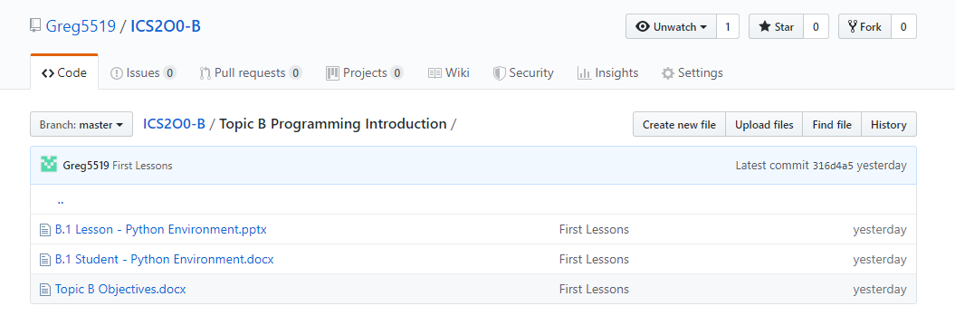

1. List some privacy concerns related to using GitHub.
2. Summarize the guidelines you should follow when creating a user account for school work on 3rd party software.
3. List some of the main features of a Terns of Service (TOS) agreement.
4. List some of the main features of a Privacy Policy.
5. Summarize the difference between a TOS and a Privacy Policy.

**Module Questions**

1. Review the Terms of Service (TOS) agreement for the GitHub service.
   1. Open the link: (<https://help.github.com/articles/github-terms-of-service/>)
   2. Summarize the section that confirms that you are permitted to use this software for this class.

The section that confirms you are permitted is Section B, account requirements. It gives all the valid information such as only humans can create this account, only one person can make a single account, must be 13 or older, login may only be one person, etc.

* 1. Explain what rights do you give up by using this software.

You lose the right of many things but mainly privacy. When using Github your work can be used,

published as well as have copies made and be added to their database to be used in the future.

* 1. Explain what limitations you have when using this software.

The limitations with Github is their overall responsibility. They are not responsible for the loss of your or third party use or inability to use the service.

1. Review the Privacy Policy for the GitHub service.
   1. Open the link: (<https://help.github.com/articles/github-privacy-statement/>)
   2. What information does GitHub collect and track?

The information Github collects and tracks varies from a lot of things. These things include your personal information and any other information you give them so it can be tracked and they can better understand their visitors.

* 1. Summarize how GitHub shares your information.

Github shares user personal information with the user's permission. Github shares the information so it can perform services that a user requested, it does not share, sell, rent or trade user information with third party applicants for their commercial use.

d.       How does GitHub communicate with you?

Github communicates with its visitors via email. However, instead of sending excess emails, it only sends emails if you have said okay and allowed Github to send it.

GitHub will be used to share course files in a similar way to MyClass or D2L. The reason we are using GitHub is because this is the tool preferred by many software developers and is the most common way to share computer code on the internet.

The Peel School Board is concerned about the privacy and safety of its students and has issued the following guidelines for using third party applications:

* Do not provide: First & Last Name
* Do not provide: Birthday
* Do not provide: Personal Address & Contact Information
* Do not provide: Student Number
* Your @pdsb.net email address can be used but cannot be used as a login id.

1. Based on your understanding of the GitHub privacy policy, list two benefits and two drawbacks of following the Peel Board guidelines listed above.  
   Two benefits that come from the Peel Board guidelines is that no information would be received from third party applicants as all sources used would be unaware of a student's personal information,  another benefit could be it allows you to secure your personal information from Github itself, there are a lot of hidden meaning written between the lines that at a glance, it looks normal but if you really go in-depth it can affect you greatly. Two drawbacks with using Peel Board guidelines are that the website will not cater to you, due to Peel Guidelines the website will not cater to you for stuff like preferred languages and fonts making it a worse experience for the user. Also, a drawback can be the lack of third party support, if you are signed up on another website with a different user then it can lack third party support as it will only recognize the Peel Board Guidelines account.

1. Create an account on GitHub.com following the Peel Board guidelines listed above.
   1. **NOTE:** Make sure to select the free student plan when creating your account.

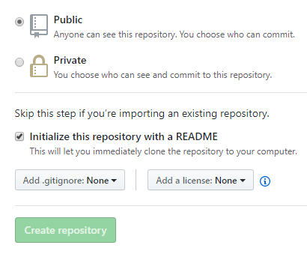

1. Create a new Repository for your ICS2O0 course work.
   1. Give your repository a meaningful name like “ICS2O0_Work”
   2. **Note:** Make sure to select "Public Repository"
   3. **Note:** Make sure to select “Include a ReadMe file”
2. Email Mr. Nestor (p0079141@pdsb.net) the following information:
3. Your Name
4. The link to your repository

Your personal GitHub repository will be used to store and manage your work for this course. You should save partially completed work in your repository and you can update it at any time from school or at home. GitHub automatically keeps track of updates to your files. You should NEVER make multiple VERSION COPIES of your work files.

Your repository should be shared with your teacher and with other members of your work group.

1. Open Mr. Nestor's repository for this class.
   1. You should have bookmarked the link in an earlier part of this lesson.
   2. This repository is the source for all course information and lesson files (much like D2L or Google Classroom is used by other teachers).
   3. Note the structure and organization of Mr. Nestor’s repository. In particular, note the folders such as “Topic A”, "Topic B", etc.
2. Duplicate the organization structure and folder names in your personal repository.
   1. Your personal GitHub repository will be used to upload and manage your work completed for this course.
   2. Your repository needs to be well organized so that Mr. Nestor can easily find your work and give you credit for it.
   3. **NOTE:** There is a “trick” required to create folders in GitHub.
   4. See if you can find this trick and share it with your neighbours.
   5. Check-in with Mr. Nestor to make sure you have found the trick.
3. Upload your answers to this module (i.e. the “A.1 Student - GitHub Repositories” )
   1. Make sure to store it in the proper folder.
   2. Use the "Upload" button in the GitHub screen and drag and drop you file.
   3. Make sure to "Commit" your changes at the bottom of the upload screen.
   4. You can upload and commit partially completed work now and then upload the same file again at a later time; GitHub automatically keeps track of your changes.

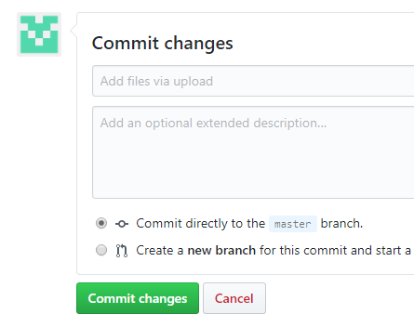

1. Email Mr. Nestor ([p0079141@pdsb.net](mailto:p0079141@pdsb.net)) when you have completed this work.

Work will be submitted (handed in) by uploading it to your repository . ONLY work uploaded to your repository will be considered handed in and will be marked.